Software Requirements Specification

for

English Dictionary

Version 1.0 approved

Prepared by

Nguyen Chau Thao Quan

Nguyen Hung Phuc

Nguyen Trung Ngoc

December 23, 2018

Table of Contents

1. Introduction 1

1.1 Purpose 1

1.2 Document Conventions 1

1.3 Definitions, Acronyms and Abbreviations 1

1.4 References 1

2. High Level Requirements 1

2.1 Product Perspective 1

2.2 Use Case Description 1

2.2.1 Diagram 2

2.2.2 User Description 6

2.2.3 Use Case Description 6

2.2.4 Use Case & User Permission Mapping 6

2.3 Operating Enviroment 6

2.4 Assumption and Dependencies 7

3. FUNCTIONAL REQUIREMENT 7

3.1 Module 01 7

3.1.1 UC01: Sign Up 7

3.1.2 UC02: Sign In 7

3.1.3 UC03: List of users 8

3.1.4 UC04: Account Personal Information 9

3.1.5 UC05: Search field 10

3.1.6 UC06: Language field 10

3.1.7 UC07: View History 11

3.1.8 UC08: Word Upload 11

4. Nonfunctional Requirements 12

4.1 Accessbility 12

4.2 Volume 12

4.3 Precision 12

4.4 Performance 12

4.5 Compatibility 12

4.6 Maintainability 12

4.7 Safety 12

4.8 Portability 13

5. System Constraint 13

5.1 Database 13

5.2 Device 13

5.3 Programming Language 13

Revision History

|  |  |  |  |
| --- | --- | --- | --- |
| **Name** | **Date** | **Reason For Changes** | **Version** |
|  |  |  |  |
|  |  |  |  |

# Introduction

## Purpose

This Software Requirement Specification version 1.0 provide a complete description of all the function and specification of the English dictionary project. This document is intended to sign the contract with the customer and to be used by the members of the software engineering team that will implement and verify the correct function of the system.

## Document Conventions

None

## Definitions, Acronyms and Abbreviations

|  |  |  |
| --- | --- | --- |
| **#** | **Abbreviation** | **Explaination** |
| 1 | SRS | Software Requirement Specification |
| 2 | UC | Use Case |
| 3 | SC | Screen |
| 4 | MS | Messages |

## References

|  |  |  |  |  |
| --- | --- | --- | --- | --- |
| **Title** | **Author** | **Version** | **Date** | **Source Location** |
|  |  |  |  |  |

# High Level Requirements

## Product Perspective

It is almost look like the common dictionary in real life, instead of buying them from bookstore, you need just access the dictionary web on the computer.

When you sign in successful, it will show you the homepage and allow you to search or upload the word meaning.

When you sign out, it will move directly to the sign in forms.

When you enter any word, it will show you the meaning of that word, audio and the description.

When you are not sign in, it will move directly into the sign in page.

## Use Case Description

### Diagram

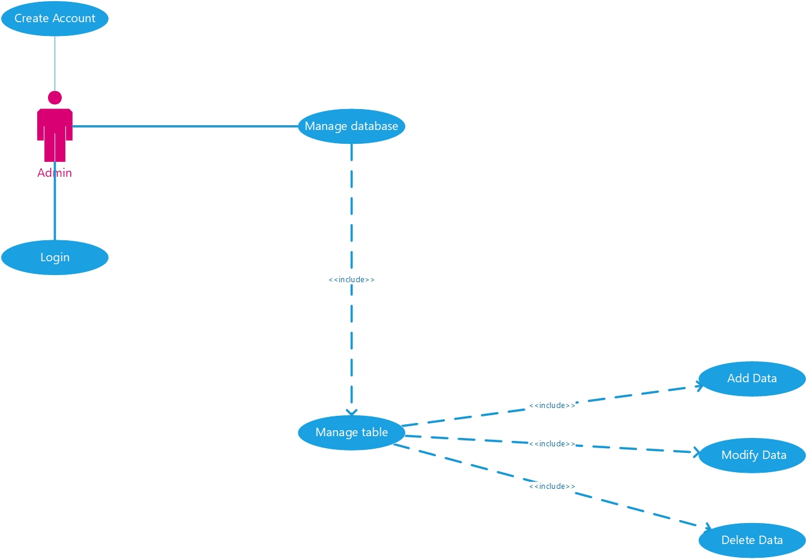

Diagram 1: Admin's Use Case

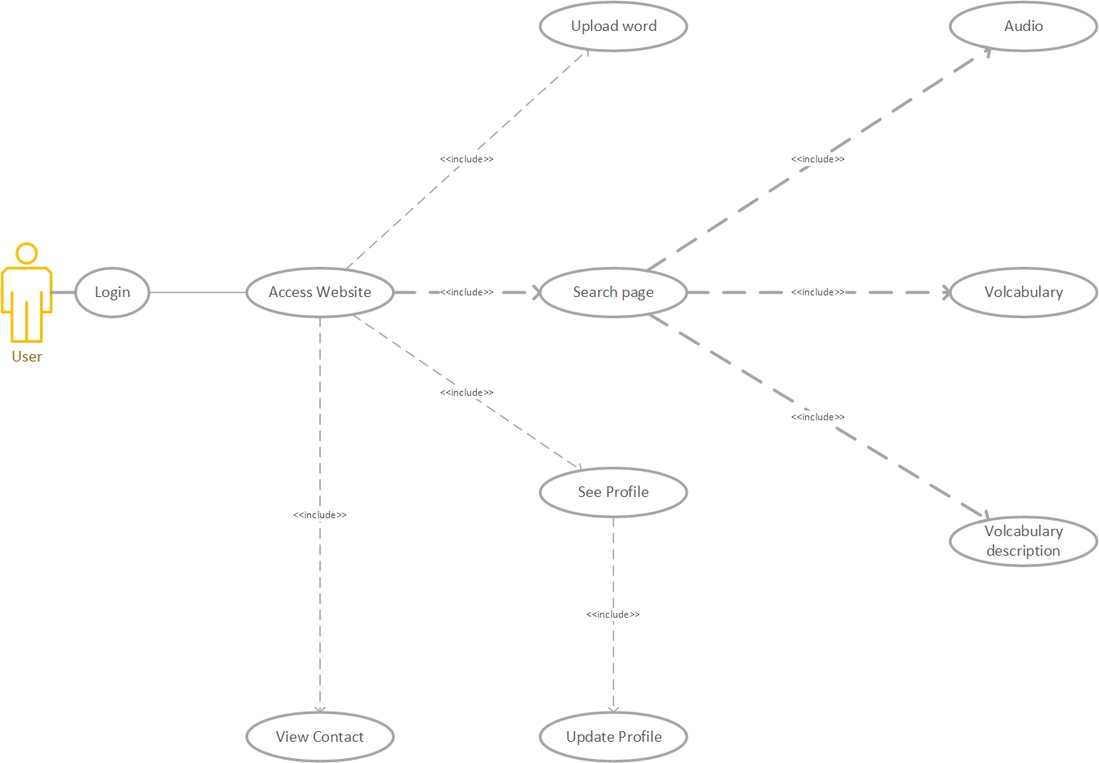

Diagram 2: User access Use case

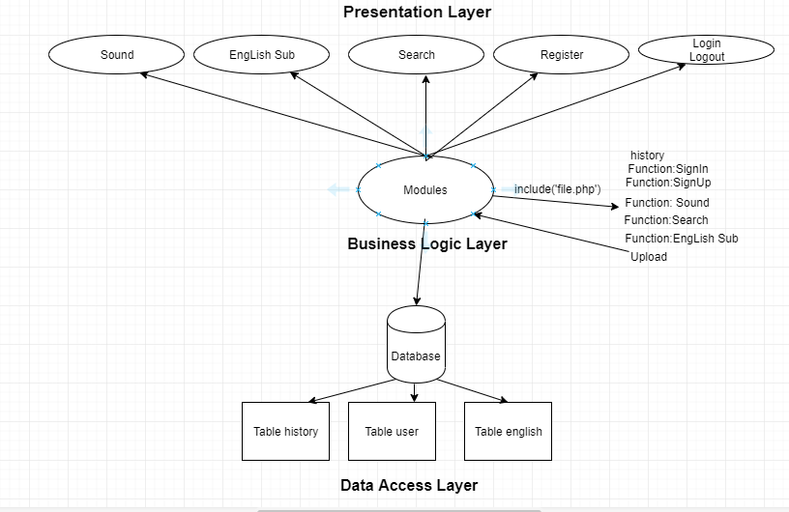

Diagram 3: Use case English Dictionary

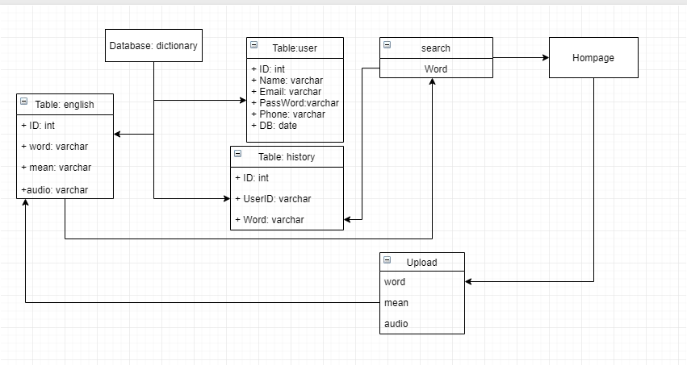

Diagram 4: Search and history, upload word

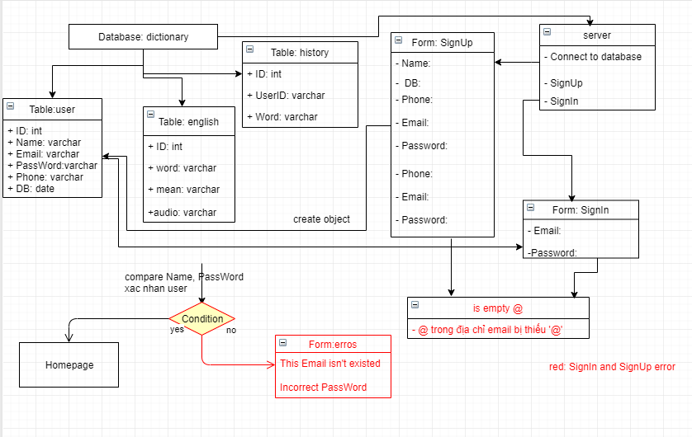

Diagram 5: SignIn, SignUp method

### User Description

|  |  |  |
| --- | --- | --- |
| **#** | **User Permission** | **Definition** |
| 1 | Admin |  |
| 2 | Account Manager |  |
| 3 | Guest |  |

### Use Case Description

|  |  |  |  |
| --- | --- | --- | --- |
| **#** | **ID** | **Name** | **Brief Description** |
| 1 | UC01 | Sign Up | User can create account to use the translate function |
| 2 | UC02 | Sign In | User can Login when they create account success |
| 4 | UC03 | Account personal information | User can see and change their personal information |
| 5 | UC04 | Search field | User can enter the words or sentences to find the meaning |
| 6 | UC05 | Description section | User can see the word they enter and the meaning of that one |
| 7 | UC06 | Audio | User can hear the sound of that word |
| 8 | UC07 | View History | User can see the words they enter all the times |

### Use Case & User Permission Mapping

|  |  |  |  |  |
| --- | --- | --- | --- | --- |
| **Use Case** | **Use Case Name** | **Admin** | **Account Manager** | **Guest** |
| UC01 | Sign Up | X | X | X |
| UC02 | Sign In | X | X | X |
| UC03 | Account personal information | X | X | X |
| UC04 | Search field | X | X | X |
| UC05 | Language field | X | X | X |
| UC06 | View History | X | X | X |
| UC07 | Upload Volcabulary | X | X | X |

## Operating Enviroment

## Assumption and Dependencies

# FUNCTIONAL REQUIREMENT

## Module 01

### UC01: Sign Up

|  |  |  |  |  |  |
| --- | --- | --- | --- | --- | --- |
| **ID** | **Name** | **Account** | **Trigger** | **Pre-condition** | **Post condition** |
| UC01 | Sign Up | Admin/Account Manager/Guest | User press the Sign Up button |  | Move to Sign Up form |

Activities

|  |  |  |  |
| --- | --- | --- | --- |
| **User** | | **System** | |
| Main flow: Sign Up Success | | | |
| 1 | User press sign up button. (SC01) |  | |
|  |  | 2 | Move to the Sign Up forms. (SC02) |
| 3 | User enter their name, email, password and tick the box I agree. |  |  |
|  |  | 4 | Validate the field and the check the password. |

System Messages

|  |  |
| --- | --- |
| MS01 | Please enter your name. |
| MS02 | Please enter your email. |
| MS03 | Please enter your password. |
| MS04 | The password is not matched. |
| MS05 | Cannot create account when the check box I agree is missing. |

### UC02: Sign In

|  |  |  |  |  |  |
| --- | --- | --- | --- | --- | --- |
| **ID** | **Name** | **Account** | **Trigger** | **Pre-condition** | **Post condition** |
| UC02 | Sign In | Admin/Account Manager/Guest | User press the Sign In button |  | Move to homepage |

**Activities**

|  |  |  |  |
| --- | --- | --- | --- |
| **User** | | **System** | |
| Main flow: Sign In Success | | | |
| 1 | User press sign in button (SC02) |  | |
|  |  | 2 | Move to the Sign In forms (SC03) |
| 3 | User enter their, email, password |  |  |
|  |  | 4 | Validate the field and the check the password. |

System Messages

|  |  |
| --- | --- |
| MS06 | Please enter your email This notification will appear when user let the email field is empty |
| MS07 | Please enter your password  This notification will appear when user let the password field is empty |
| MS08 | The password isn’t correct  This notification will appear when user enter the wrong password |
| MS09 | The Email isn’t correct This notification will appear when user enter the wrong email. |

### UC03: Account Personal Information

|  |  |  |  |  |  |
| --- | --- | --- | --- | --- | --- |
| **ID** | **Name** | **Account** | **Trigger** | **Pre-condition** | **Post condition** |
| UC03 | Account Personal Information | Admin/Account Manager/Guest | User press the Account detail |  | Move to personal information page |

Activities

|  |  |  |  |
| --- | --- | --- | --- |
| **User** | | **System** | |
| Main flow: Sign Up Success | | | |
| 1 | User press personal information detail(SC06) |  | |
|  |  | 2 | Move to the personal information page (SC07) |
| 3 | User enter their new name, email, password. |  |  |
|  |  | 4 | Validate the field and the check the password by request their password again. |
| 5 | User enter the password to confirm |  |  |
|  |  | 6 | Notice when user type successful or not |

System Messages

|  |  |
| --- | --- |
| MS13 | Password is not match this message will appear when 2 password from user are not match |

### UC04: Search field

|  |  |  |  |  |  |
| --- | --- | --- | --- | --- | --- |
| **ID** | **Name** | **Account** | **Trigger** | **Pre-condition** | **Post condition** |
| UC04 | Search field | Admin/Account Manager/Guest | Admin/Account Manager/Guest enter any word or sentences and press search button. |  | Find the specific word to translate. Get data in Table(english) from database(dictionary) and user will see ‘Word, mean’ and listening ‘audio’. |

Activities

|  |  |  |  |
| --- | --- | --- | --- |
| **User** | | **System** | |
| Main flow: Search successful | | | |
| 1 | User enter the words or sentences. |  | |
|  |  | 2 | Check this is words or not Check this is sentences or not. |
| 3 | Translate from English to Vietnamese or vice versa. |  |  |

System Messages

|  |  |
| --- | --- |
| MS11 | This is not the words The word or sentence that user entered contain the special characters. |

### UC05: Language field

|  |  |  |  |  |  |
| --- | --- | --- | --- | --- | --- |
| **ID** | **Name** | **Account** | **Trigger** | **Pre-condition** | **Post condition** |
| UC05 | Language field | Admin/Account Manager/Guest |  |  | Translate a word or a sentence from English to Vietnamese or vice versa |

Activities

|  |  |  |  |
| --- | --- | --- | --- |
| **User** | | **System** | |
| Main flow: Search successful | | | |
| 1 | Enter a word which don’t have any special characters. |  |  |
|  |  | 2 | Translate this word from English to Vietnamese when user enter the word to search correct. |

### UC06: View History

|  |  |  |  |  |  |
| --- | --- | --- | --- | --- | --- |
| **ID** | **Name** | **Account** | **Trigger** | **Pre-condition** | **Post condition** |
| UC06 | View History | Admin/Account Manager/Guest | Admin/Account Manager/Guest click the view history button |  | See the word they looked up |

Activities

|  |  |  |  |
| --- | --- | --- | --- |
| **User** | | **System** | |
| Main flow: View History page | | | |
|  |  | 1 | Show the user the word history list |

### UC07: Word Upload

|  |  |  |  |  |  |
| --- | --- | --- | --- | --- | --- |
| **ID** | **Name** | **User** | **Trigger** | **Pre-condition** | **Post condition** |
| UC07 | Word Upload | All user can upload file audio, English… | User click the upload button in topbar menu |  | See the form of the upload page |

Activities

|  |  |  |  |
| --- | --- | --- | --- |
| **User** | | **System** | |
| Main flow: View Upload form | | | |
|  |  | 1 | Show form of the upload page ( include the word, audio link and html link). |

# Nonfunctional Requirements

## Accessbility

User enter 1 character and show the list of the words that have that character.

User can use their voice to fill the word automatically.

## Volume

Number of user can access at least 100 peoples.

## Precision

The word must be translated when the words or sentenced have uppercases in any location.

The word received from user’s voice must be filled corect.

Audio must be spoken correct depends on the description.

## Performance

The word that user look up show the result under 5s.

The web application is responsive.

## Compatibility

The application must run on web browser.

The application run on windows 7 or higher.

## Maintainability

The software is divided into several small modules so it is easy to upgrade and maintain.

All functions can be possibly colliped.

Add more functions when needed.

## Safety

The account management system will check the account activity when the bad behavior appear (pollitic, system security,…).

System will check the virus inside the file or link when upload.

## Portability

The application run on device with any hardware:

* PC or laptop with minimum CPU core 2 duo, 2GB of rams or modern one.

# System Constraint

## Database

The application translate the word by query through firebase or MySQL.

## Device

The application run only on destop or laptop.

## Programming Language

Can write with the scripting language(HTML/CSS,JavaScript,PHP,...) or high level language (C/C++, python,java,...).

# Mockup Screen

## Welcome Screen

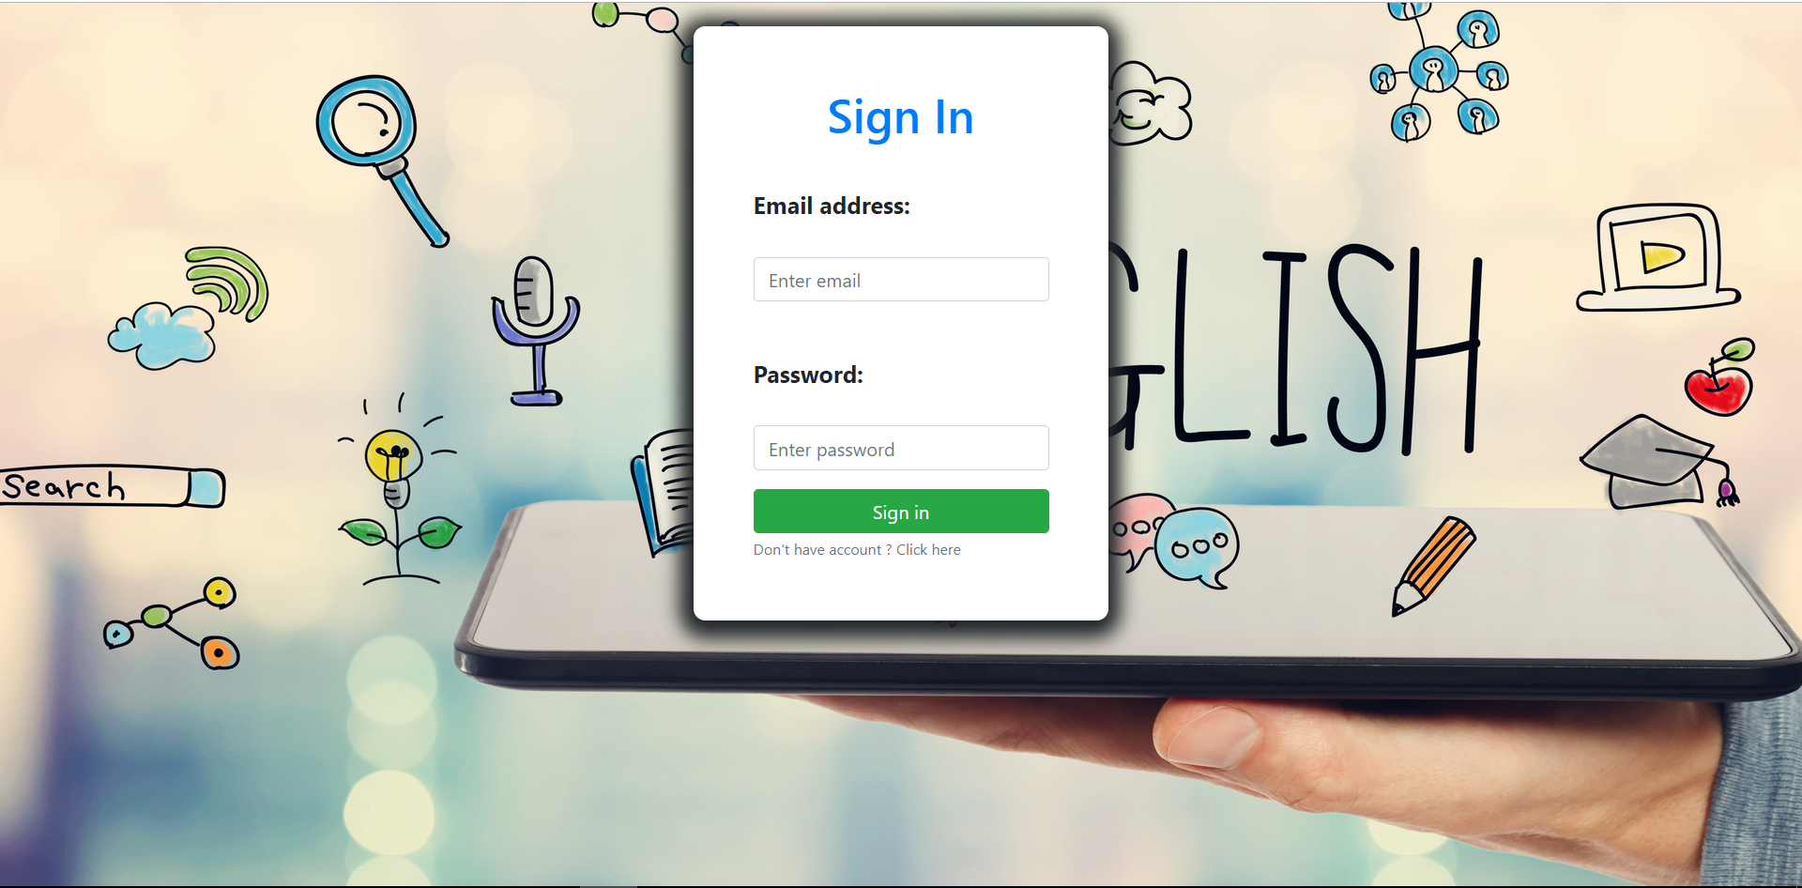

User must enter their email and password to access into homepage.

## Homepage

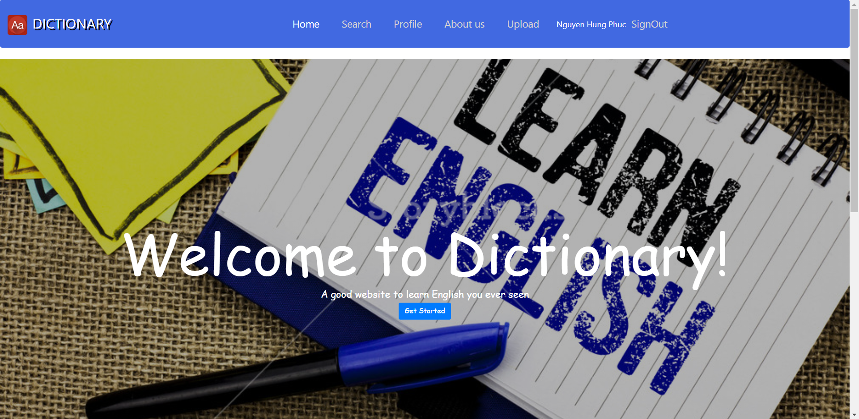

When user press the Search in top bar menu or Get Started button, it will switch into the dictionary page

## Dictionary page

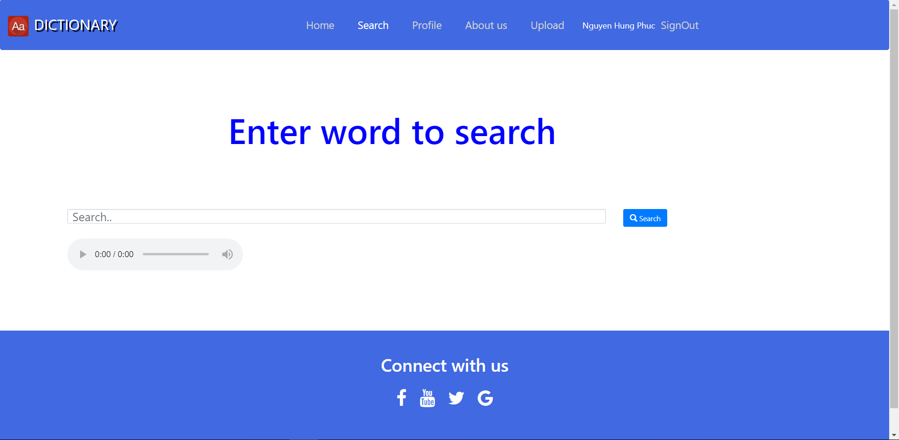

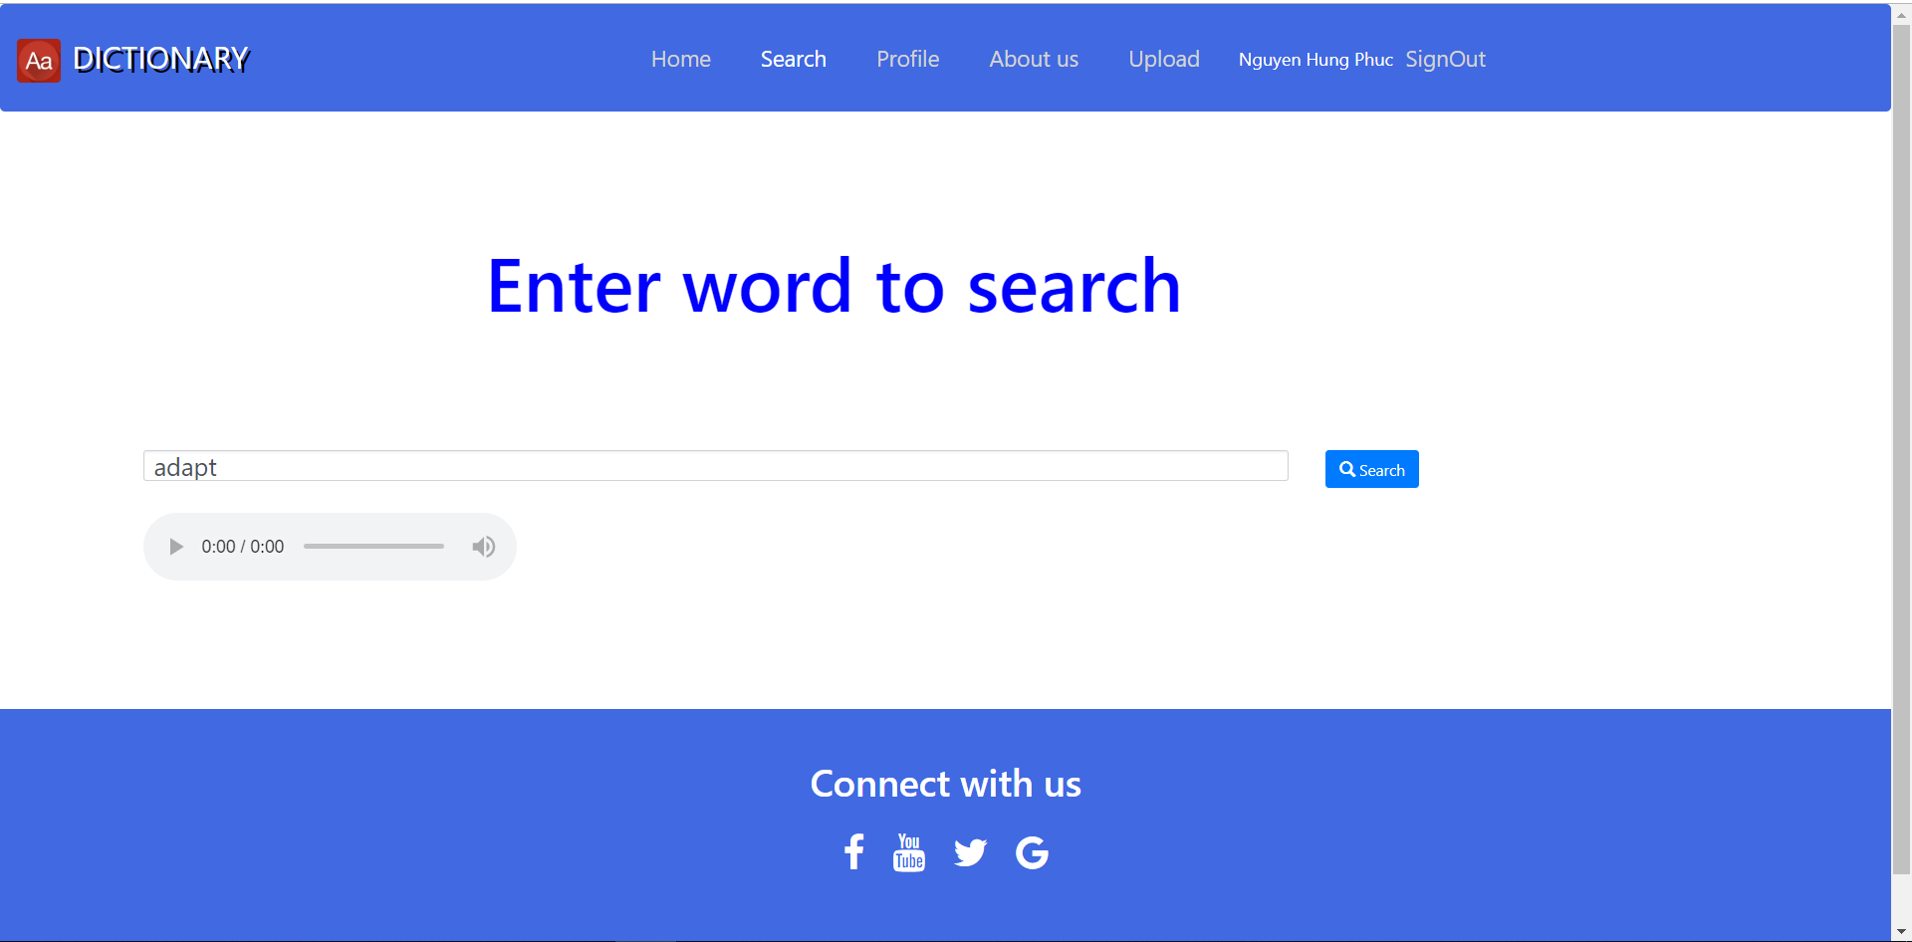

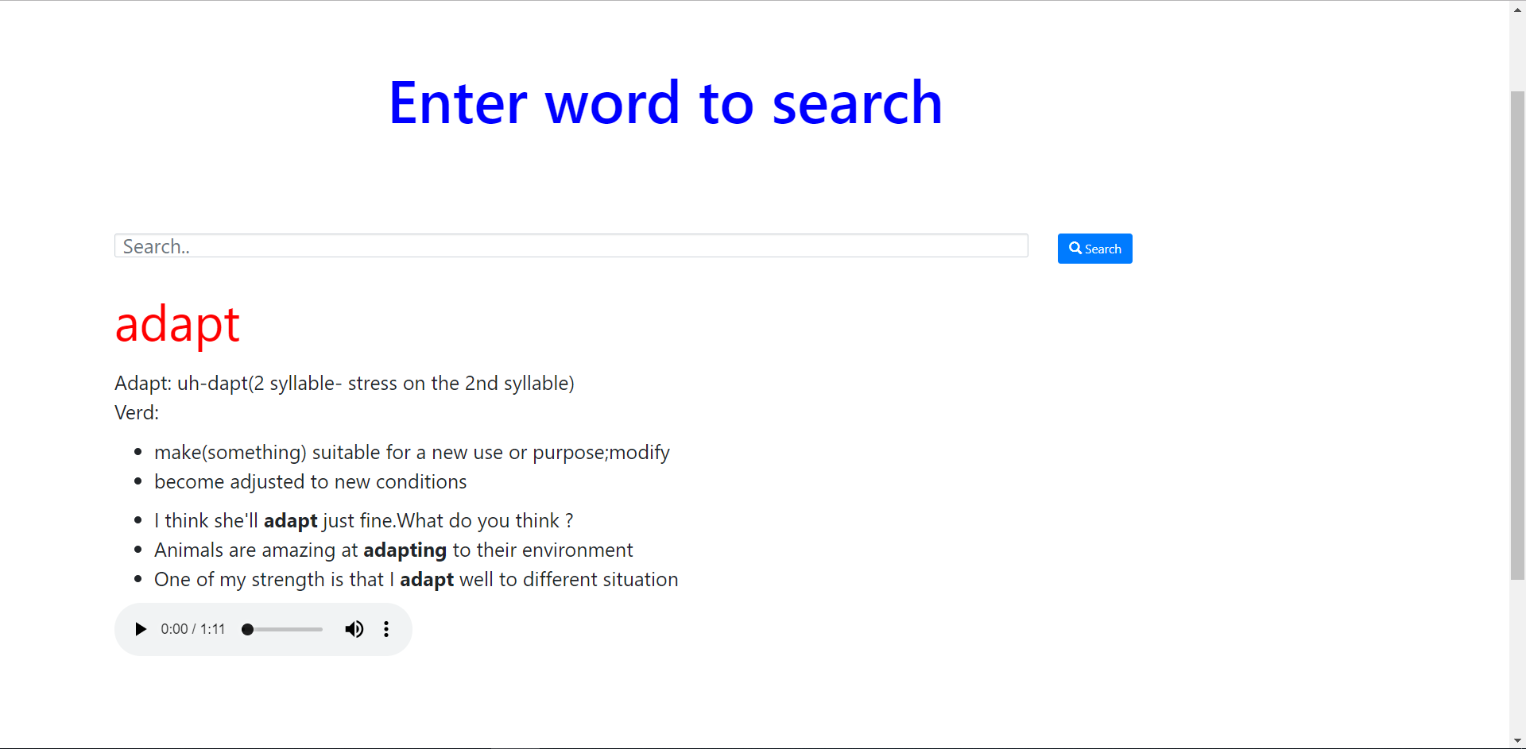

When user enter the word in Search field and press the button Search, the data will get data from the database and view it below, user can press the play button to hear the pronounciation and the description of that word.

## Profile Page

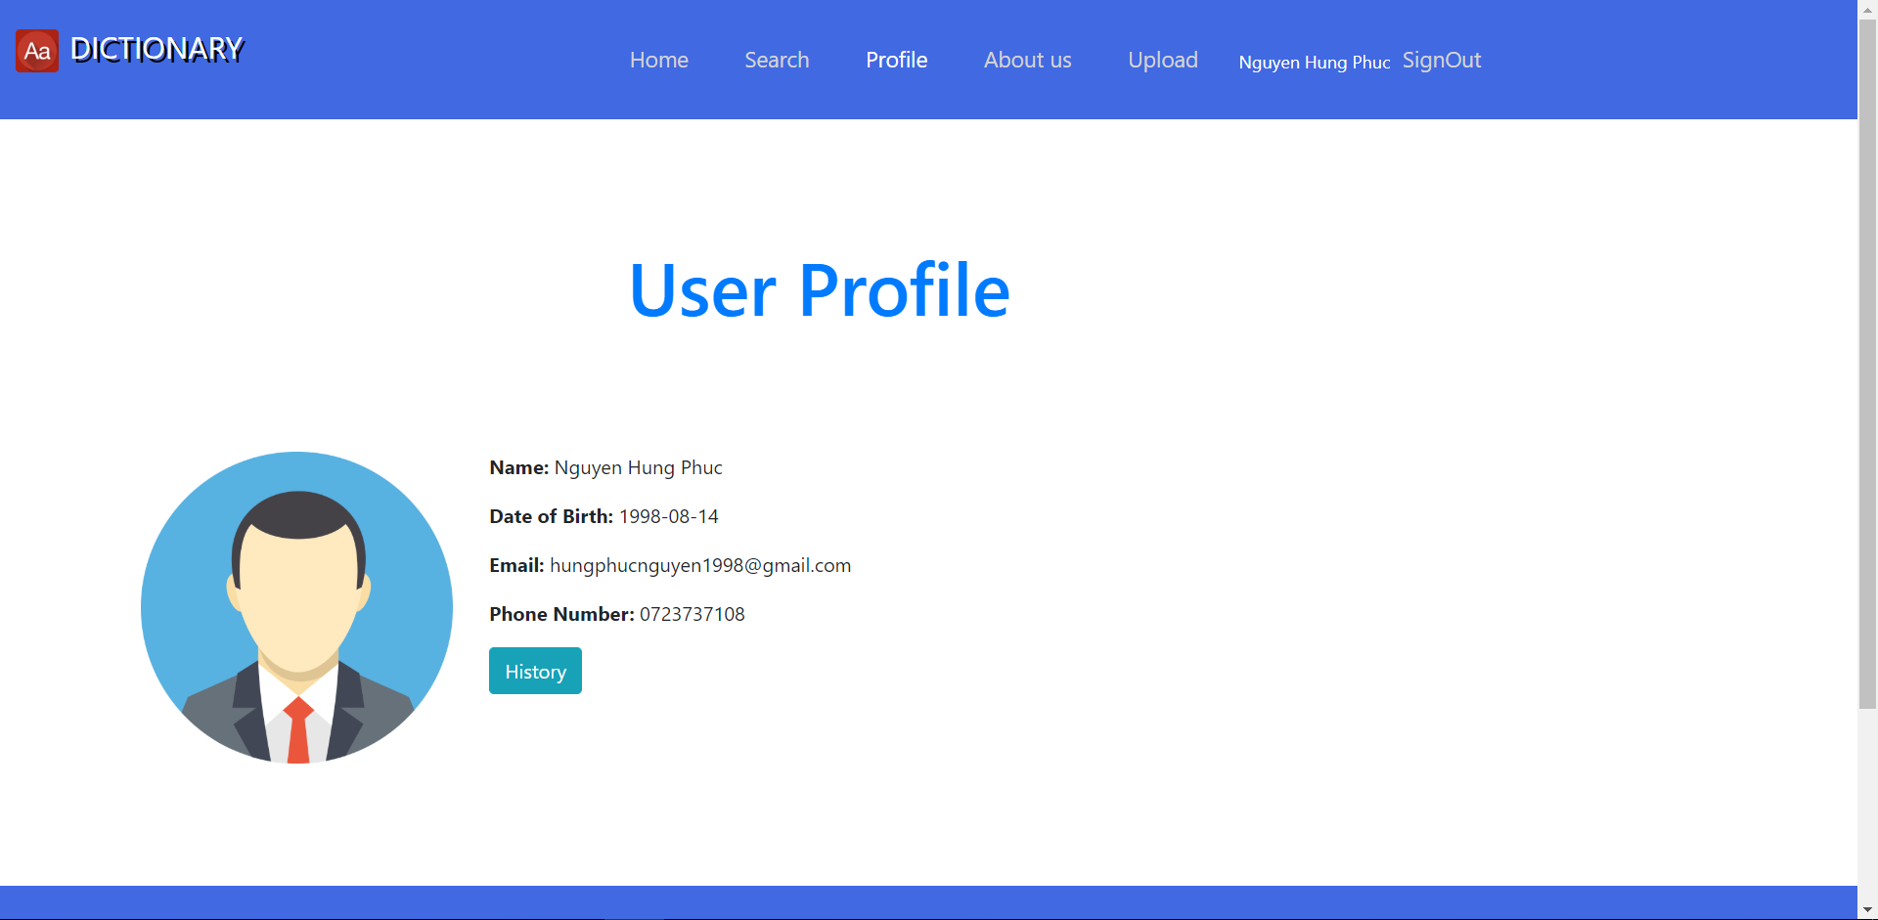

When user press their name or Profile in topbar menu, the user profile page will show the user information.

## Upload Page

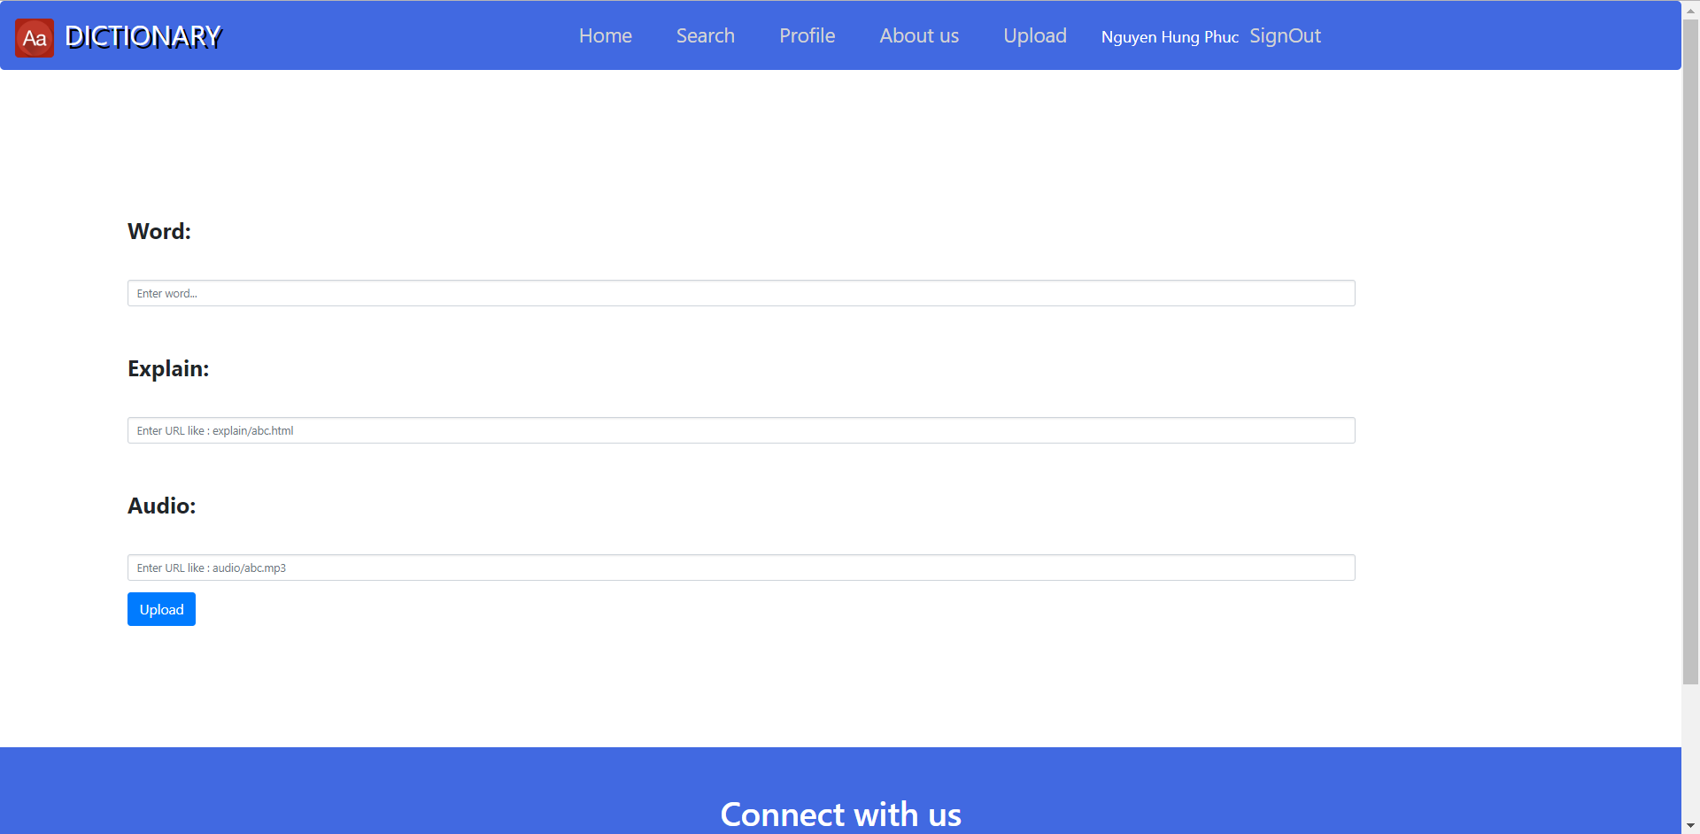

User can upload their own word in the 1st field, the link or directory of the file which contain the description of that word in the 2nd and the link or directory of the audio in the 3rd field.